**VISVESVARAYA TECHNOLOGICAL UNIVERSITY**

Jnana Sangama, Belgaum-590014.



**DBMS MINI PROJECT SYNOPSIS**

**ON**

**" BEAUTY PARLOUR MANAGEMENT SYSTEM"**

**Submitted in partial fulfilment of the requirement for the award of the Degree of**

**BACHELOR OF ENGINEERING**

**IN**

**COMPUTER SCIENCE & ENGINEERING**

**Submitted by:**

**Name USN**

**C H TEJASHWINI 1KN17CS024**

**MERCY RABECAL P 1KN17CS052**

**Under the guidance of Under the guidance of**

**Mr.Mohammed Ziaulla Mr.Mohammed Ghouse**

**Asst.Professor, Dept of CSE, Asst.Professor, Dept of CSE**

**KNSIT,Bangalore-64 KNSIT,Bangalore-64**



**DEPARTMENT OF COMPUTER SCIENCE AND ENGINEERING**

**K.N.S. INSTITUTE OF TECHNOLOGY**

**Bangalore – 560 064**

**2019-2020**

**INTRODUCTION**

Beauty is the gift of god and transmitted from one to the other generation. The beauty parlour shop is the need of every age of men women and children famous poet keats defined the word beauty as : " A thing of beauty is a joy for ever: Beauty parlour is a very important shop to make the people good looking by application of cosmetics treatment of hair and nourishment of skin by various methods . Life style is fast changing in the modern era and the women have become more conscious about their make up the status of women has improved a lot and is improving further. This has resulted in their life style changing. Also their economic independence encourages them to resort this type of services.

From the ages past people have used sandal wood oil turmeric powder and milk etc. For the treatment of skin but now people have become more educated they need proper and professional treatment of skin hairs nails and tooths. Every man women and child want to be beautiful. A good beauty parlour is required in every city town and other places. A beauty parlour with all modern facilities and services at reasonable charges more visit can be expected from each individuals due to the scarcity of experience and qualified beautician their is immense marketability for this venture.

ABSTRACT:

The beauty parlour management system is a project prepared by using PHP, MySQL. It is basically classified into items like hair cutting, nourishment of hair, dyeing of hair, prevention of hair fall, facial, treatment of pimples, pedicure etc. Maintain the beauty centre information in the beauty centre system registry so that the settings can be read and written directly from the skin care registry.

**OBJECTIVE:**

Beauty parlour is a service oriented establishment in which women receive treatment to increase their beauty. Skin care, facial make up, hair nourishment and model hair cutting are the most important nourishing activities of a beauty parlour. The use of machinery, ayurvedic formulations and approved synthetic chemicals and medicines vary from person to person as per need. In present project the provision of different beauty therapy are present with use of limited number of machinery.

**SCOPE OF THE BEAUTY PARLOUR PROJECT**

Current scope of the beauty parlour project is to beauty parlour management system project in java check the state of the beauty parlour services and drivers, state of the beauty parlour processes, state of drivers the skin care, cosmetic treatments and hair salon application doesn’t provide any method to work with these aspects of the beauty parlour management.

**PURPOSE OF THE BEAUTY PARLOUR PROJECT**

* Provide a Single environment from where an administrator can interact with the beauty shop system resources within the beauty centre network.
* Provides Info regarding the beauty parlour no of services running on the beauty centre system.
* To provide an upgrade support for the beauty shop system resources.
* Provides interface to interact with the beauty shop system parameters like network settings, OS Settings, Services, and Process etc.
* Provides means of reporting the beauty parlour system setting to a person through email. There by an administrator can know the status of the systems throughout the network.

**PROBLEMS IN THE BEAUTY CENTRE EXISTING SYSTEM**

* The current system is provided by Microsoft Corporation, but requires a person to know the methodology to interact with the beauty shop system configuration.
* Not a single interface to monitor all the free download project report events. Don’t notify to the Spa salon user in case any event generated errors.
* System resources cannot be freed frequently based on the beauty centre parameters.
* Administrator is not notified regarding any failure by the skin health system.
* The current system doesn’t allow the remote access of the beauty parlour resources of one system with other·
* Three different Categories are provided to know the current status of the beauty parlour services, drivers etc.

**HARDWARE & SOFTWARE SPECIFICATIONS**

* **Software Requirement Specifications**

Operating System : Windows 10

Front End : JSP (Java Server Pages)

Back End : Oracle 11g

Server : XAMPP server

Documentation : Microsoft Office 2010

* **Hardware Requirement Specifications**

|  |  |
| --- | --- |
| Computer Processor | Core i3 |
| Processor Speed | 2.3 GHz Processor |
| Hard Disk | 20 GB or more |
| RAM | Min 2GB |

**ENTITY RELATIONSHIP DIAGRAM**

An entity relationship diagram (ERD) shows the relationships of entity sets stored in a database. An entity in this context is a component of data. In other words, ER diagrams illustrate the logical structure of databases.

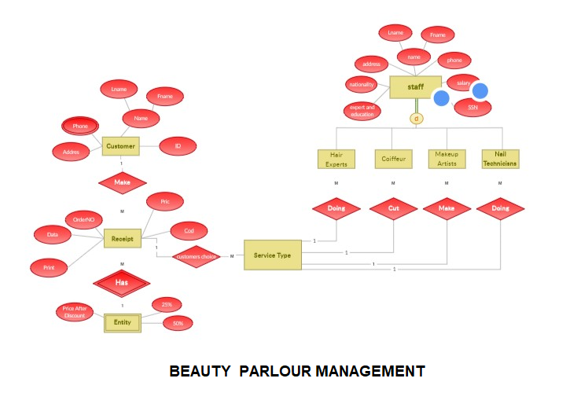

**BIBLIOGRAPHY&REFERENCES**

**REFERENCES USED:**

* Google for solving the problem.
* Head first Java 2nd edition.
* Java and Software Design Concepts by Apress.
* Database Programming with JDBC,CSS.
* <http://www.jsquery.com/javascripts>
* <http://www.xampp.com/server>
* <http://google.com>.
* <http://w3schools.com>.
* http://www.carrentingsolutions.com/
* http://www.flashvortex.com/
* http://www.imscart.com/car_rental_software.html
* Wikipedia.org